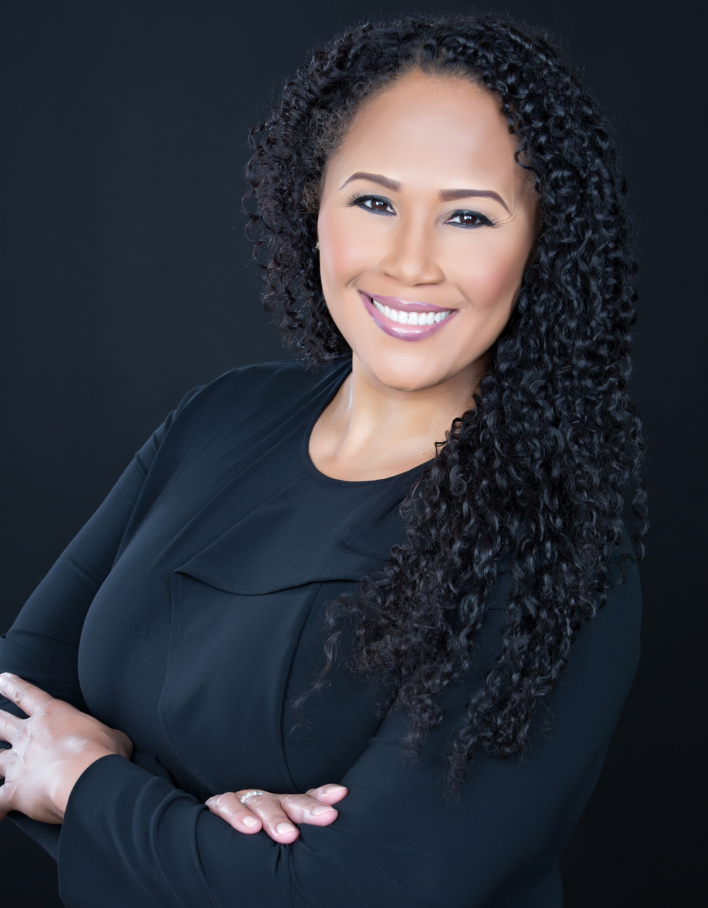 | Name: Lauren Lacey
 | Company Name: US Foods, Inc.
 | Current or Most Recent Role: Associate General Counsel, Nationally Managed Business
 | Are You The Top Legal Officer – GC/CLO? No
To whom do you report (Title):
Associate General Counsel, Commercial
Education: University of Virginia - JD, 1998; BA 1995 | Company Revenue and Market Cap: $24 Billion; $7.95 Billion Market Cap
Law School Graduation Date: 5/1998 | Public? Yes
GC Sponsors:  (GCs or former GCs who recommends you as a Ready Now Fortune 1000 GC)  Juliette Pryor - GC, Cox Enterprises; Angie Morris - GC, Allstate Canada; Laurie Oare - SVP, National Sales, US Foods; Susan Angele – Sr. Board Adviser, KPMG; Chris Scalia - Chief Talent Officer, The Hershey Company | Primary Area(s) of Practice/Experience (explain): Commercial contracting, distribution, regulatory (marketing, advertising, promotions, claims substantiation, product development, ant-kickback/safe harbor), government contracts; litigation; legal operations
Any Geographical Preferences or Restrictions? Open to any location (domestic/international); Preference for Mid-Atlantic and Southeast US | Law Firm Experience (firms, years practice areas):  Goodell DeVries (boutique trial firm, 5.5 years) - managed own litigation docket, including 2nd chairing five trials (medical malpractice, class actions)
Prior In-House Titles: US Foods - Associate GC, National Sales & Legal Operations  The Hershey Company - Associate GC - North America, Americas, Global Growth; Lead Counsel, Global Marketing & Sales; Marketing Counsel | Industry Experience: Consumer products, Manufacturing, Food & Beverage, Distribution
Contact Information:  LHCLacey@gmail.com  443-790-4432  105 Wisner St, Park Ridge, IL 60068 | Size of the Largest Team Managed (explain):  Team of 10 at Hershey - 4 attorneys (globally); 5 paralegals, 1 assistant
Explain level of Corporate Governance and Corporate Board Room Experience:  No direct experience | In which of these critical areas do you have experience -- M&A, Securities, Corporate Governance, Finance, Litigation Management, Compliance, Regulatory and Enterprise Risk Assessment? Please explain.  15 years with public companies, including with US Foods during its 2016 IPO; guided business on public company mindset and modified business practices
Experience with Public Company Securities Issues: 15 years with public companies, including with US Foods during its 2016 IPO; guided business on public company mindset and modified business practices | International Experience:  The Hershey Company (China, Canada, Mexico, Brazil, Caribbean) - business partner to: President, North America (US/Canada); President, Americas; SVP Chocolate SBU; SVP Sweets & Refreshments SBU
Summary of Experience/Bio: (300 words or less)
Lauren Lacey is a strategic legal business partner who provides legal, regulatory and business advice to successfully achieve company results while driving business strategies. Lauren's brand is characterized by trusting relationships at all levels, strong commercial acumen and the ability to provide practical solutions across a broad commercial landscape, both globally and domestically. While at US Foods for 3+ years, Lauren has supported the nationally managed business ($13B), routinely negotiating and advising on multi-million dollar agreements with large customers in healthcare, hospitality, government, restaurant chains and group purchasing organizations. She also created the legal operations function including department budgeting and operating plans, and established a contracting center of excellence. Lauren's prior 10 years at The Hershey Company is characterized by progressive responsibility from an FDA regulatory/litigation manage/eDiscovery specialist, to a marketing/advertising/claims/trademark adviser, to sales/antitrust compliance leader, and ultimately, as business partner to C-suite executives responsible for geographic and functional business units in the US, Canada, Mexico, Brazil and China. Prior to her in-house experience, Lauren was a litigator with Goodell DeVries defending hospitals, pharmaceutical/medical device companies and insurers in class actions, personal injury and product liability cases.

